Project Design Phase-II
Technology Stack (Architecture & Stack)

Date | 01 July 2026
Team ID
Project Name | Customer Registry
Maximum Marks | 4 Marks

Technical Architecture:
The deliverable includes the architectural diagram below and the information as per Table-1 & Table-2.

Architecture Diagram: Customer Registry
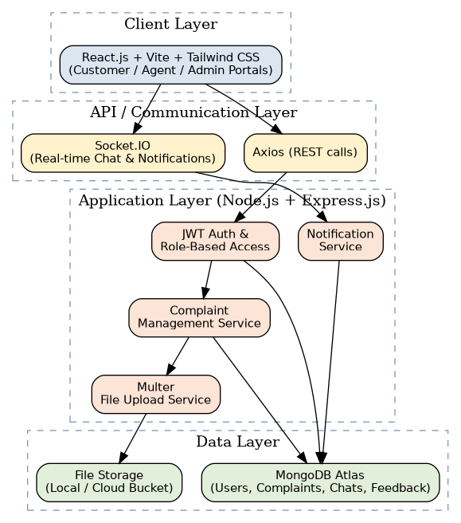

Table-1: Components & Technologies
S.No | Component | Description | Technology
1. | User Interface | How users interact with the application (Customer, Agent, Admin portals) | React.js, Vite, Tailwind CSS, Axios
2. | Application Logic-1 | Authentication & role-based authorization | Node.js, Express.js, JSON Web Token (JWT), bcrypt
3. | Application Logic-2 | Complaint lifecycle management (create, assign, update, track) | Node.js, Express.js, Mongoose ODM
4. | Application Logic-3 | Real-time communication (chat & live notifications) | Socket.IO
5. | Database | Data type, schema, and configuration for users, complaints, chats, feedback | MongoDB (NoSQL, document-based)
6. | Cloud Database | Managed database service on cloud | MongoDB Atlas
7. | File Storage | Storage for complaint attachments/proof documents | Multer (upload handling) with local/cloud storage (e.g., Cloudinary)
8. | External API-1 | Sending email confirmations and status notifications | Nodemailer / SMTP Email Service
9. | External API-2 | Not applicable in current scope | N/A
10. | Machine Learning Model | Not used in the current scope (future scope: complaint category auto-classification) | N/A
11. | Infrastructure (Server / Cloud) | Application deployment on cloud  Local Server Configuration: Node.js runtime, local MongoDB instance  Cloud Server Configuration: Render/Vercel (frontend & backend), MongoDB Atlas (database) | Render, Vercel, MongoDB Atlas

Table-2: Application Characteristics
S.No | Characteristics | Description | Technology
1. | Open-Source Frameworks | Frameworks used to build the application | React.js, Node.js, Express.js, Mongoose, Tailwind CSS
2. | Security Implementations | Access controls and protections implemented | JWT-based auth, bcrypt password hashing, Helmet, CORS policy, input validation
3. | Scalable Architecture | Justification of scalability (3-tier / microservices-ready) | Stateless REST API (3-tier: presentation, application, data) deployable across multiple instances
4. | Availability | Justification of application availability | Cloud hosting with managed uptime (Render/Vercel) and MongoDB Atlas replica sets
5. | Performance | Design considerations for performance (requests/sec, caching) | Database indexing, pagination, React lazy loading, memoization (useMemo/useCallback)

